**Plots and Summaries of Models for Sales Data Q1**

**Plot of sales data**

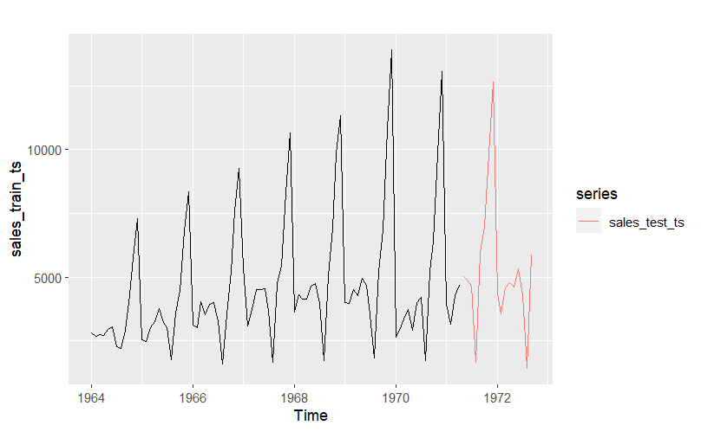

**ACF PLOT**

**PACF PLOT**

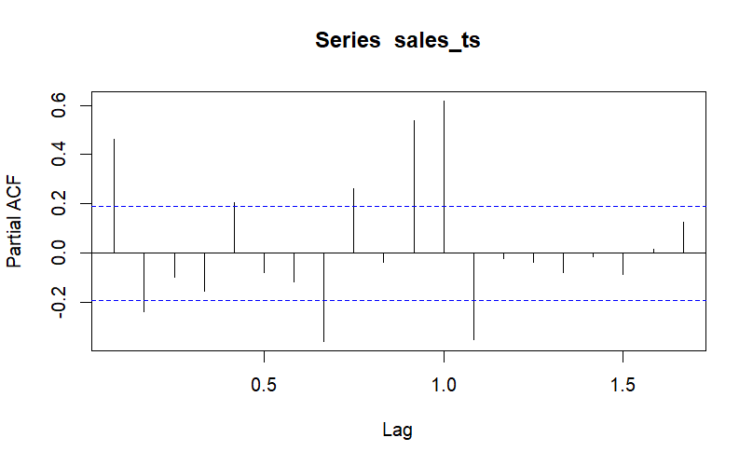

**LAG PLOTS**

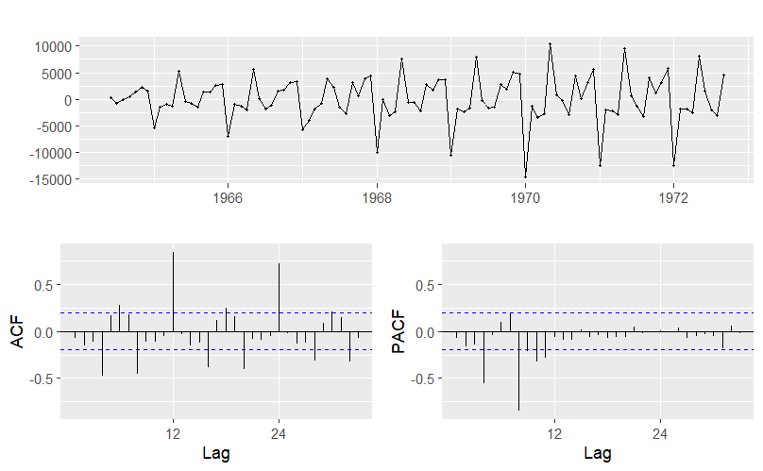

**Model summary of Model1 and Model 2**

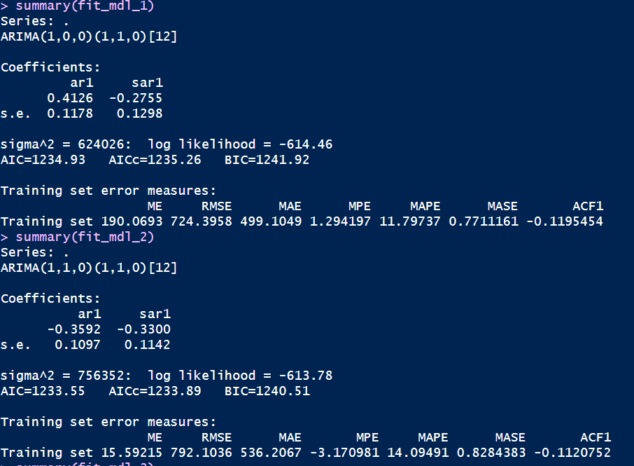

**Model summary of Models 3 and 4**

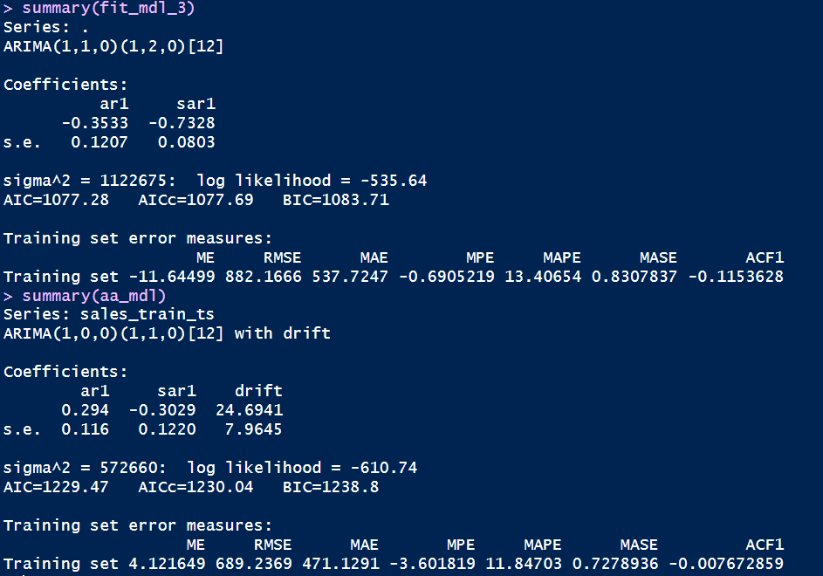

**Forecast data with confidence intervals with model 4 which has least RMSE**

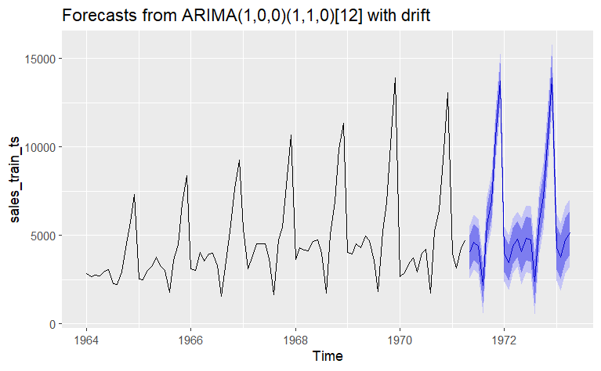

**Forecast plot with actual vs forecast data**